EV3 Switches Assessment

- How do you know which branch is True and which is False in a controlled Switch Block?

- Ziffle writes this straight line Obstacle Detection program. What happens when the program is run?
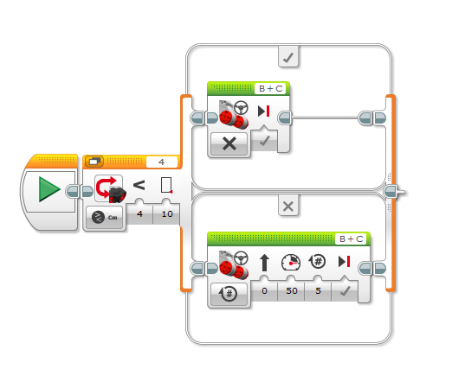
3. Would this program work for 5 obstacles? Why or why not?

